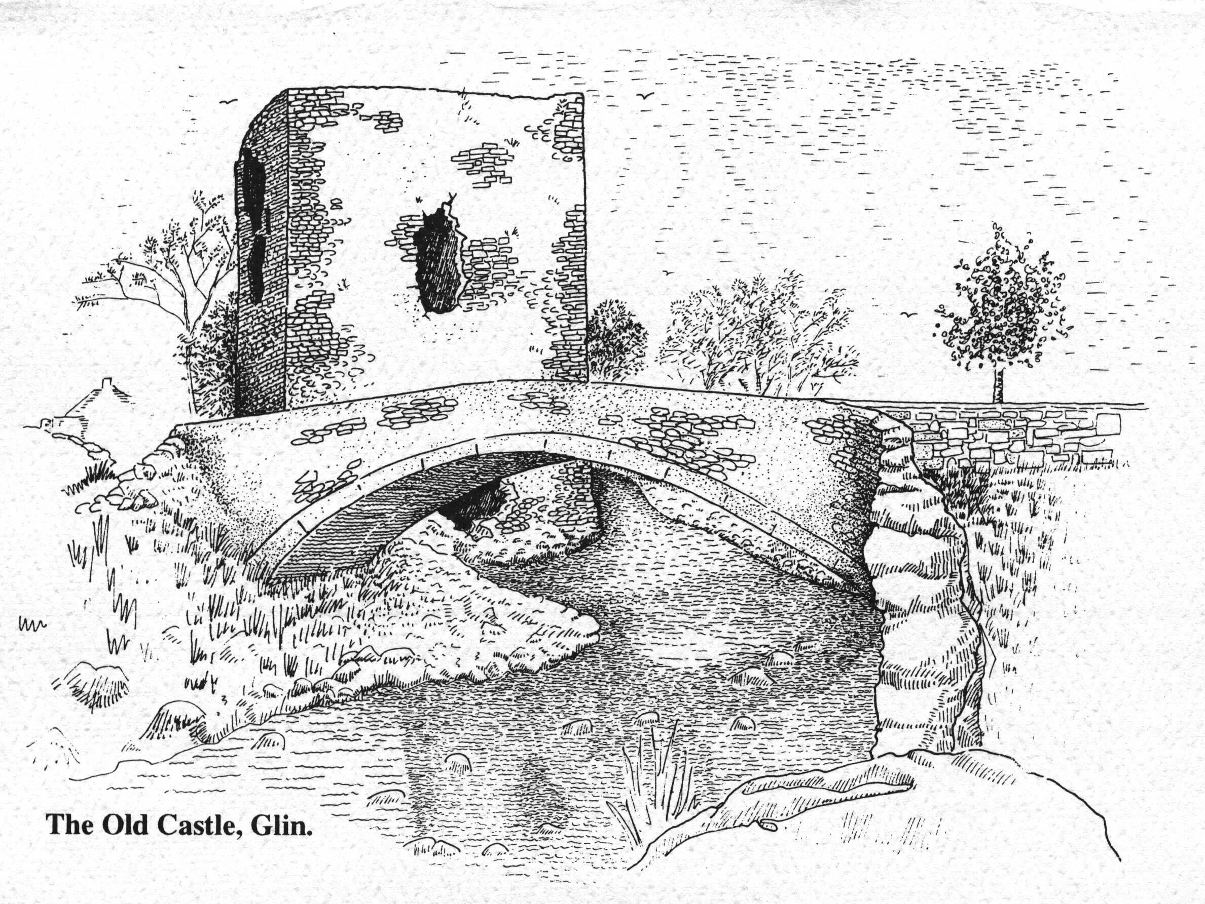

St. Fergus’ National School, Glin

Relationships and Sexuality Education (RSE) Policy 2025
Adopted January 2026 | Next Review January 2028

Introductory Statement and Context
This Relationships and Sexuality Education (RSE) Policy was comprehensively reviewed and updated by the Board of Management of St. Fergus’ National School, Glin in October and November 2025. The review aligns with the Primary Curriculum Framework, the Department of Education Circular 0067/2025 (Primary Curriculum for primary and special schools) and the most recent OIDE Guidance for SPHE and RSE. It supersedes the school’s previous RSE Policy (2014) and reflects the integration of RSE within the broader context of Social, Personal and Health Education (SPHE), the Bí Cineálta Policy 2025, Child Protection Procedures 2025 and the Child Safeguarding Statement of St. Fergus’ NS 2025.
St. Fergus’ NS affirms that parents are the first and primary educators of their children, particularly in the areas of relationships, human dignity, and moral formation. The school supports parents in this role by providing learning experiences that promote the integral development of the human person—spiritual, moral, emotional, social, intellectual and physical—recognising each child as created in the image and likeness of God.
This policy reaffirms the school’s commitment to fostering the holistic development and wellbeing of every child, grounded in the Catholic ethos of the school and in partnership with parents, who are recognised as the primary educators of their children. It ensures that RSE is delivered in a structured, spiral, and age-appropriate manner across all class levels, consistent with the values of respect, inclusion and dignity for each individual.
The policy also ensures full compliance with Department of Education Guidance around SPHE and RSE, 0041/2025 (Child Protection Procedures for Schools), and all relevant national frameworks, including the Wellbeing Policy Statement and Framework for Practice. It draws explicitly on approved Departmental resources — Stay Safe, Walk Tall, and the Relationships and Sexuality Education Resource Materials — as well as guidance from Making the Links (PDST, 2018) to support effective, evidence-based and inclusive teaching and learning in RSE.
School Ethos and Philosophy
St. Fergus’ National School is a co-educational Catholic primary school under the patronage of the Bishop of Limerick. Rooted in the Gospel values of love, respect and compassion, the school seeks to nurture the full and balanced development of every child—spiritual, moral, emotional, intellectual, social and physical—in accordance with the Catholic ethos and the vision for holistic education outlined by the Department of Education and Youth.
The Relationships and Sexuality Education (RSE) programme is delivered in this context, promoting the dignity and worth of every human person as created in the image of God. It encourages pupils to appreciate the sacredness of life, the importance of family, friendship and community and the responsibilities that come with human relationships. The policy acknowledges that parents are the primary educators of their children and that the school’s role is to complement and support them by providing age-appropriate, sensitive and values-based education that is consistent with both the Catholic tradition and national educational policy.
Through this partnership, RSE in St. Fergus’ NS upholds the Department of Education and Youth’s Wellbeing Framework for Practice by fostering respect, inclusion, empathy and moral discernment—core values that underpin both Catholic education and the national curriculum vision for the child as an active, caring and responsible citizen.
The RSE programme in St. Fergus’ NS is delivered in harmony with the Grow in Love programme, which articulate the Catholic vision of the human person, the sacredness of life, the value of relationships and the importance of family and community.
Definition and Purpose of RSE
Relationships and Sexuality Education (RSE) is a key and mandatory component of the Social, Personal and Health Education (SPHE) curriculum and plays a central role in the holistic development of every child in St. Fergus’ National School. RSE enables pupils to acquire a sound understanding of human growth and development, human relationships and the responsibilities that come with the gift of life and love. It is grounded in the principles of respect, dignity and inclusion and is delivered in a developmental and age-appropriate manner that supports the spiritual, moral and emotional formation of each pupil.
In line with the Primary Curriculum Framework and OIDE/RSE Guidance, RSE at St. Fergus’ NS provides structured learning experiences that foster the development of positive self-identity, empathy, responsible decision-making and interpersonal skills. Through carefully sequenced lessons, pupils are supported to explore themes such as friendship, belonging, emotions, personal safety, growing and changing, puberty and reproduction, within the context of respect for self and others.
The programme is delivered in accordance with the Catholic ethos of the school, promoting an understanding of relationships and family life. It encourages pupils to appreciate the sacredness of human life, to recognise sexuality as a God-given gift and to develop the moral capacity to form loving, respectful and life-giving relationships. RSE in a Catholic school is rooted in the belief that sexuality is a gift from God and an integral part of the whole person. The programme seeks to develop pupils’ understanding of human love, respect for themselves and others and the moral responsibilities that accompany human relationships.
In accordance with Department of Education Circulars 0022/2010 and 0067/2025, RSE is implemented as an integral strand of SPHE, ensuring that learning in the areas of personal safety, emotional wellbeing, human growth and development and relationships is continuous and spiral in nature. The programme is supported through the Stay Safe, Walk Tall and RSE Resource Materials (DES-approved) as well as complementary materials identified in Making the Links (OIDE). Together, these ensure a comprehensive, evidence-based and values-informed approach that empowers pupils to understand themselves, relate to others with care and respect and participate responsibly within family, school, and wider community life.
RSE within SPHE and the Wider Curriculum
Relationships and Sexuality Education (RSE) is delivered as an integral component of Social, Personal and Health Education (SPHE) and forms part of the school’s whole-school approach to wellbeing, personal development and moral formation. It is embedded within the strands and strand units of the SPHE Curriculum
- Myself,
- Myself and Others and
- Myself and the Wider World
and is supported through cross-curricular connections with Religious Education, Science, Physical Education and the Wellbeing Framework.
The implementation of RSE in St. Fergus’ National School follows the guidance set out in OIDE’s Making the Links and Beyond (2018), which maps content across the Stay Safe, Walk Tall and RSE programmes to ensure spiral, balanced and developmental coverage across all class levels. This two-year strand-based cycle enables pupils to encounter the same key themes—such as personal safety, emotional development and growth and change—at progressively deeper and more mature levels as they move through the school.
The Stay Safe Programme is taught as a mandatory child protection and safety strand in accordance with Circular 65/2011 and the Child Protection Procedures for Schools (2025). The Walk Tall Programme promotes healthy lifestyle choices, self-esteem and resilience, while the Relationships and Sexuality Education Resource Materials (DEY) provide structured guidance on sensitive objectives related to friendship, growing and changing, puberty and reproduction. Together, these core resources ensure compliance with the SPHE Curriculum (1999), Primary Curriculum Framework (2023), and Department of Education Circular 0067/2025.
In keeping with the school’s Catholic ethos and under the patronage of the Bishop of Limerick, RSE is enriched by the Grow in Love Religious Education Programme, which nurtures pupils’ spiritual and moral development and deepens their understanding of the dignity of human life, love and family.
Additional complementary resources such as Webwise and HTML Heroes support the development of digital citizenship, online safety and respectful communication, in line with the Department of Education and Youth’s Wellbeing Framework for Practice and OIDE Wellbeing and RSE resources.
Through this integrated, cross-curricular and values-based approach, St. Fergus’ NS ensures that RSE is not an isolated subject but a living expression of the school’s commitment to the holistic formation of every child—spiritually, emotionally, intellectually and socially—within a caring Catholic community that upholds both the ethos of the patron and the principles of national educational policy.
Aims and Objectives of RSE
Through the RSE programme, pupils are supported to:
- Develop a positive sense of self, self-worth and personal responsibility. Pupils will be guided to recognise their inherent dignity as individuals created in the image of God, to value their unique talents and abilities and to develop self-confidence and resilience. RSE encourages the growth of self-awareness and respect for oneself as the foundation for forming healthy and caring relationships with others.
- Understand the nature of relationships and the importance of family life. Pupils will explore the variety of loving and supportive relationships that exist in their lives—within families, friendships, school and community. They will learn that family, in its many forms, provides belonging, security and love and that stable and caring relationships contribute to human flourishing and to the common good.
- Acquire the knowledge and skills necessary for personal safety, protection and wellbeing. Through lessons supported by the Stay Safe and Walk Tall programmes, pupils will develop the confidence and strategies to make safe choices, recognise unsafe situations, respect personal boundaries and seek help from trusted adults. They will also learn about digital safety, bodily integrity and the importance of consent, in line with the St. Fergus NS Child Safeguarding Statement (2025) and Department of Education and Youth circulars.
- Develop the ability to make informed, responsible and ethical decisions. Pupils will learn to apply moral reasoning and empathy when making choices, considering the rights and feelings of others. RSE encourages critical reflection, discernment and personal responsibility, enabling pupils to act with integrity, compassion and respect in both personal and social contexts.
- Explore the emotional, biological and social aspects of growing and changing. Pupils will learn about physical and emotional development, puberty, reproduction and human growth in an age-appropriate way. This will include understanding that change is a natural part of life and that every person experiences it uniquely. Lessons promote body positivity, respect for privacy and appreciation for the wonder of life and creation.
- Appreciate the dignity of human life and the gift of sexuality in the context of relationships. In harmony with the school’s Catholic ethos and the Grow in Love Religious Education Programme, pupils will be guided to understand sexuality as a sacred and life-giving gift. They will learn that human love is expressed most fully in caring, faithful and committed relationships and that life is to be valued and protected at every stage.
Together, these aims underpin a comprehensive, values-based RSE programme that equips pupils with the knowledge, understanding, attitudes and skills necessary to develop as confident, caring and responsible members of society—emotionally secure, morally aware and spiritually enriched.
6. Whole School Approach and Parental Involvement
Parents are the primary educators of their children in all matters relating to relationships, human development and sexuality. At St. Fergus’ National School, we view our role as one of partnership and support, complementing the education provided at home by delivering structured, age-appropriate and values-based lessons within a caring Catholic environment.
In accordance with Department of Education and OIDE guidance, Relationships and Sexuality Education (RSE)forms a mandatory part of the SPHE curriculum for all pupils. It is designed to help children develop knowledge, understanding, skills and attitudes that promote their wellbeing, safety and respect for themselves and others. Lessons are taught in a sensitive, factual and inclusive manner, consistent with the school’s Catholic ethos and under the patronage of the Bishop of Limerick.
Parents will be informed in advance when sensitive areas of the RSE programme—such as lessons on growing and changing, puberty or conception—are being taught. They are strongly encouraged to familiarise themselves with the official RSE Curriculum, which is available on the Department of Education website and through the OIDE SPHE/RSE resources portal, so that they can see exactly what is being taught, at what class level and how it is presented. This transparency aims to allay any anxieties or misconceptions and to promote confidence in the professional and values-based approach taken by teachers.
Parents are always welcome to discuss the content of the RSE programme with the class teacher or the Principal before making any decision regarding withdrawal. The school encourages open dialogue so that concerns can be addressed, resources can be reviewed together and the shared aims of home and school can be upheld.
While the teaching of RSE is compulsory for schools, parents retain the right to withdraw their child from particular sensitive elements of the RSE programme only after consultation with the school and by completing the RSE Parental Withdrawal Form (Appendix B). In such cases, parents are expected to assume responsibility for teaching the relevant content themselves, in accordance with the Department of Education and Youth expectations.
The Board of Management and staff encourage all parents, wherever possible, to allow their children to participate in the full RSE programme. These lessons are designed to help children build self-esteem, confidence, safety awareness and respect for others—foundations that contribute to lifelong wellbeing and healthy relationships. By maintaining open communication, mutual respect and trust, St. Fergus’ NS and parents work together to ensure that every child receives a balanced, holistic and values-centred education.
The school’s approach echoes the teaching of the Catholic Church, that parents have a God-given responsibility for the moral and faith formation of their children. The school acts in a supportive role, ensuring that teaching is consistent with Catholic moral teaching and the pastoral guidance of the Bishop of Limerick, our Patron.
Curriculum Implementation
The Relationships and Sexuality Education programme is taught by all class teachers as an integral part of the Social, Personal and Health Education (SPHE) curriculum and in accordance with the Primary Curriculum Framework and Department of Education Circular 0067/2025. The Framework emphasises that SPHE—including RSE—forms a key component of the Wellbeing area of learning, with a recommended minimum allocation of one hour per week for all pupils from Junior Infants to Sixth Class. This dedicated time ensures that the personal, social, emotional and moral dimensions of education receive explicit and consistent attention throughout the school year.
In St. Fergus’ National School, RSE is taught both discretely and through integration with other curricular areas such as Religious Education, Science and Wellbeing. Each teacher is responsible for the planning, delivery and assessment of RSE content appropriate to their class level, following a two-year strand cycle as outlined in our SPHE Policy This structure ensures that all pupils experience a broad and balanced RSE programme which revisits key themes—such as friendship, belonging, safety and growth—at developmentally appropriate stages.
In St. Fergus’ NS, all classes teach STAY SAFE lessons at the same time over the course of the number of weeks needed to complete the programme for that class level. We always use a Team Teaching Approach to these classes, which means that two teachers are present in the room at all times during these lessons. The planning for the conducting of these classes rests with the pair of teachers involved.
RSE lessons are delivered through approved Department of Educationand Youth resources, namely:
- Stay Safe
- Walk Tall
- Relationships and Sexuality Education Resource Materials.
These are further supported by Grow in Love (Religious Education), Webwise/HTML Heroes (digital wellbeing), and OIDE Wellbeing and RSE Resources . All materials are reviewed in advance by teachers to ensure that content is both age-appropriate and consistent with the school’s ethos.
In the senior classes (5th and 6th), specific emphasis is placed on preparing pupils for the changes associated with puberty, relationships and responsible decision-making. In keeping with Department and HSE best practice, “Growing Up” talks based on the Busy Bodies Programme (HSE) are delivered in alternate years, to ensure that all pupils receive these lessons before transitioning to post-primary school. (May/June 2026 is the next cycle of lessons) The class teacher usually teaches all lessons but if for whatever reason, this is not possibleand an external speaker is conducting the lessons, they or a senior member of teaching staff, remains present at all times during these sessions, which are guided by the Busy Bodies Booklet and web links (HSE-approved). Parents are informed in advance of the content, provided access to the resources and encouraged to discuss the material with their children at home.
All teaching follows a spiral curriculum approach, meaning that key concepts are revisited with increasing depth and complexity as pupils mature. Lessons are delivered through active and participatory methodologies—discussion, reflection, circle time, role play and story—allowing pupils to develop not only knowledge but also empathy, communication and moral discernment. The implementation of RSE is monitored by school leadership to ensure consistency, inclusivity and alignment with both Department of Education expectations and the ethos of St. Fergus’ NS.
Sensitive Topics – Approach, Management, and Methodologies
In St. Fergus’ National School, sensitive topics are taught with sensitivity, accuracy and respect for both the ethos of the school and the developmental stage of each pupil. These topics are delivered in full compliance with Department of Education guidance and the principles of inclusion, dignity and empathy outlined in the school’s Bí Cineálta Policy 2025.
Sensitive areas are taught in a manner consistent with the Catholic moral tradition, which emphasises the dignity of the human body, respect for life and the value of committed, loving relationships as the proper context for sexual intimacy, while acknowledging the diverse lived experiences of pupils and families.
Sensitive content within the RSE curriculum includes, but is not limited to, topics such as:
* Naming of body parts using correct anatomical terms (e.g. penis, vulva, womb, urethra C.F. Appendix A)
* Awareness of new life and understanding how babies grow and are cared for
* Puberty and the physical and emotional changes it brings
* Menstruation, wet dreams and the importance of personal hygiene
* Human reproduction, conception and birth within the context of loving, committed relationships
* Respect for personal boundaries, privacy and consent
* Recognising and celebrating different family structures and relationships built on care, kindness and mutual respect.
These themes are introduced gradually through the spiral curriculum structure set out in the SPHE Framework. The content is revisited and developed at appropriate class levels—from early awareness of growth and care in the infant classes, to puberty and reproduction in the senior classes—ensuring that pupils receive consistent, factual and values-based education.
In accordance with Department guidance, the class teacher always remains with the class during any lesson that includes sensitive topics, even where an external facilitator or guest speaker is invited to assist. This ensures continuity of care, respect for school ethos and alignment with the St. Fergus’ NS Child Safeguarding Statement (2025).
The Bí Cineálta Policy underpins how these lessons are approached, emphasising kindness, empathy, respect for difference and the use of inclusive language when discussing topics that may be sensitive or personal. Children are encouraged to express curiosity and feelings in a safe, supportive environment where kindness and confidentiality are central. Teachers model this respectful communication throughout, helping pupils to recognise that learning about their bodies, emotions and relationships is a normal and important part of growing up.
Teaching methodologies include;
- active learning,
- class discussion,
- circle time,
- reflection,
- question boxes,
- storytelling,
- diagram work, and
- sorting activities.
All lessons are age-appropriate,inclusive and differentiated to support the diverse needs of learners, including pupils with additional needs. Teachers use anatomically correct and respectful terminology, in line with OIDE’s recommended language grid (Appendix A), avoiding slang or euphemisms. The use of consistent, factual vocabulary fosters understanding and reduces stigma or embarrassment when discussing human development.
Across all stages, the teaching of sensitive topics is values-driven, promoting care for self and others, respect for privacy, responsibility in relationships and appreciation for the sacredness of life. By integrating the OIDE guidance with the relational values of Bí Cineálta pupils learn that discussions about their bodies, emotions and relationships are to be approached with honesty, kindness and respect—key principles that underpin both our school ethos and our wider approach to wellbeing.

Dealing with Questions and Confidentiality
Teachers will use discretion when responding to pupil questions, ensuring answers remain within the curriculum and school ethos. Where questions fall outside the agreed programme, children will be referred to parents.
Teachers will not provide personal information or advice beyond curricular content. Confidentiality cannot be guaranteed in matters of child protection - any disclosures will follow the Child Safeguarding Statement and DLP procedures.
Use of External Speakers
From time to time, external speakers or facilitators may be invited to support the delivery of aspects of the Relationships and Sexuality Education programme in St. Fergus’ National School. Their contribution can enrich pupils’ learning by providing specialist knowledge, practical insights and additional perspectives on wellbeing and health education. However, the primary responsibility for the delivery of RSE rests with the class teacher and external input must always complement—not replace—the planned programme of instruction.
In full accordance with Department of Education Circular 0022/2010, Child Protection Procedures for Schools (2025), and RSE Policy Guidance:
- The class teacher remains present for the entire duration of any session or presentation delivered by an external visitor. This ensures that the material covered aligns with the approved curriculum, is taught in an age-appropriate and sensitive manner and reflects the ethos and policies of the school.
- The Principal must approve all external facilitators and resources in advance of their use. Any materials, slides, videos, or handouts must be reviewed beforehand to ensure compliance with Department guidance and the school’s ethos.
- External contributors must be Garda vetted, operate within the parameters of the school’s Child Safeguarding Statement and adhere to all relevant sections of the Children First Act (2015).
- Visitors must conduct their work in a manner that upholds the principles of kindness, respect and inclusivity outlined in the school’s Bí Cineálta Policy 2025. They must ensure that discussions are respectful of all pupils’ backgrounds and beliefs and that sensitive topics are addressed with care and professionalism.
External input—such as the Busy Bodies Programme (HSE) or other recognised resources—is intended to enhance, rather than replace, the RSE curriculum already delivered by class teachers through Stay Safe, Walk Tall and RSE Resource Materials. The integration of such input is carefully planned to maintain coherence, developmental progression and consistency of message.
Following any external session, teachers will facilitate follow-up lessons and reflective discussion to consolidate understanding, clarify questions and ensure that the learning remains consistent with the school’s Catholic values and Wellbeing Framework.
By maintaining this structured and collaborative approach, St. Fergus’ NS ensures that all external contributions support the school’s ongoing commitment to providing high-quality, values-based RSE that is safe, inclusive and compliant with all current Department and Child Protection guidance.
11. Inclusion, Differentiation and SEN
At St. Fergus’ National School, inclusion is central to the delivery of the Relationships and Sexuality Education programme. RSE is designed and implemented in line with the Universal Design for Learning (UDL) framework and the Continuum of Support to ensure that every child—regardless of ability, learning need, family background, culture, or faith—can access meaningful and developmentally appropriate learning.
In keeping with Catholic social teaching and the vision of human dignity outlined in The Catholic School, RSE in St. Fergus’ NS values every child as a unique and unrepeatable gift from God. All pupils are welcomed, supported and included regardless of ability, background or family circumstance.
Particular attention is given to pupils enrolled in the Classes for children with Autism and to those with learning difficulties or additional educational needs in mainstream settings. Teachers collaborate closely with the Special Education Team (SET), SNAs and parents to ensure that RSE lessons are delivered in a way that supports each pupil’s communication profile, sensory needs and emotional readiness. This may include the use of visual schedules, simplified or concrete language, social stories, visual timetables, structured role-play, repetition and one-to-one pre-teaching or follow-up. Lessons are paced carefully, allowing additional processing time and opportunities for clarification.
All RSE lessons seek to affirm and include the lived experiences of children from diverse family backgrounds, including one-parent families, blended families, families with same-sex parents, children in foster care and families from different cultural or ethnic traditions. The programme also respects and welcomes pupils of other faiths or of no religious affiliation, ensuring that discussions of human relationships, love and moral decision-making are presented in a way that reflects Catholic values of dignity, respect and compassion, while also recognising and valuing diversity of belief and experience within the school community.
Teachers differentiate instruction through multiple means of engagement, representation and expression, in line with UDL principles. Resources are adapted as needed—for example, using visuals, storyboards, concrete materials or simplified texts—to make key concepts accessible and to support comprehension and participation for all learners.
Inclusion is underpinned by the Bí Cineálta Policy, which promotes empathy, kindness, respect for difference and the use of inclusive language when discussing relationships, families and identity. Class discussions emphasise belonging, self-esteem and mutual respect, creating a safe and supportive environment where every pupil feels valued and heard.
Ongoing communication with parents and guardians is an essential part of this inclusive approach. Teachers consult with families to identify any specific supports or adjustments that may assist their child in accessing RSE content and advice may also be sought from external professionals such as NCSE, NEPS or OIDE where appropriate.
Through this holistic and compassionate approach, St. Fergus’ NS ensures that RSE is accessible to all pupils, including those from the Classes for pupils with Autism, pupils with additional needs and those from diverse family or faith backgrounds. Every child is supported to understand themselves, their relationships and their place in the world with confidence, dignity and kindness.
12. Assessment and Record Keeping
Assessment in Relationships and Sexuality Education forms an integral part of the broader SPHE assessment process and contributes to the school’s ongoing commitment to supporting pupil wellbeing, personal growth and the development of positive relationships. The focus of assessment in RSE is formative and developmental, aiming to recognise progress in pupils’ understanding, attitudes and skills rather than to measure achievement in a traditional academic sense.
Teachers assess RSE through a range of approaches, including:
- Teacher observation, to identify pupils’ engagement, empathy and understanding of concepts such as respect, safety and friendship;
- Class and group discussion, to gauge pupils’ ability to express feelings, opinions and moral reasoning appropriately;
- Pupil self-assessment and reflection, allowing children to recognise their own learning, growth and confidence in understanding personal development and relationships; and
- Feedback and conferencing, enabling pupils to discuss what they have learned and how it relates to their own lives and wellbeing.

Assessment practices align with the Primary Curriculum Framework and the Assessment in the Primary School Curriculum: Guidelines for Schools, ensuring a balance between observation, dialogue, reflection and teacher judgement. Teachers record progress informally through notes, reflection templates or SPHE planning and assessment grids, in keeping with the school’s Assessment Policy.
Where pupils with additional needs—such as those in the Classes for pupils with Autism or pupils with learning difficulties—require differentiated instruction or support, assessment focuses on personal growth, social participation and understanding at each pupil’s developmental level as outlined in the Continuum of Support.
All assessment and recording practices adhere strictly to the school’s Child Safeguarding Statement and Data Protection Policy. Any sensitive information arising from RSE lessons (for example, pupil disclosures or concerns) is documented confidentially, shared only with the Designated Liaison Person (DLP) or DDLP in their absence as appropriate and dealt with in accordance with the Child Protection Procedures for Primary Schools
Through reflective and ethical assessment practices, St. Fergus’ NS ensures that RSE contributes meaningfully to pupils’ overall development—helping each child to recognise their self-worth, build respectful relationships and make informed, caring and responsible decisions.
13. Links with Other Policies
This RSE Policy is to be read alongside the following St. Fergus’ NS policies:
• SPHE Policy
• Bí Cineálta Policy
• Child Safeguarding Statement
• Code of Behaviour
• Digital Learning and Acceptable Use Policy
• Admissions Policy
This list is not exhaustive

14. Monitoring, Review and Ratification
This Relationships and Sexuality Education Policy was reviewed and updated in November 2025 in accordance with Department of Education guidance, OIDE RSE Resources and the Primary Curriculum Framework. It was formally ratified by the Board of Management of St. Fergus’ National School at its meeting on the 10th of December 2025, following consultation with teaching staff, the Parents’ Council and the school patron.
This policy is implemented under the patronage of the Bishop of Limerick. Any updates to Catholic guidance on RSE issued by the Irish Catholic Bishops’ Conference, Catholic Schools Partnership, or the Diocese of Limerick will be incorporated into future reviews.
The policy will be reviewed again in November 2027, or earlier if necessary, to reflect any changes in legislation, Department circulars, or curriculum developments, or in response to school self-evaluation findings. Interim reviews may also take place should new national guidance or child protection requirements arise.

The Board of Management affirms its commitment to ensuring that this policy remains a living and dynamic document, embedded in the daily practice of the school and reflective of its Catholic ethos, its partnership with parents, and its dedication to the holistic wellbeing and education of every pupil.

Signed: _________________________________
Fr. Liam Enright
CHAIRPERSON
Date: __________________

Appendix A: OIDE Sensitive Topics by Class Level
Junior Infants – Awareness of new life; mention of baby in the womb.
Senior Infants – Naming of body parts: penis, vagina, womb.
1st & 2nd Class – Understanding new life; birth of a baby; umbilical cord and breastfeeding.
3rd & 4th Class – Stages of baby development in womb; introduction to puberty.
5th & 6th Class – Menstruation, puberty, conception and birth within a loving relationship context.
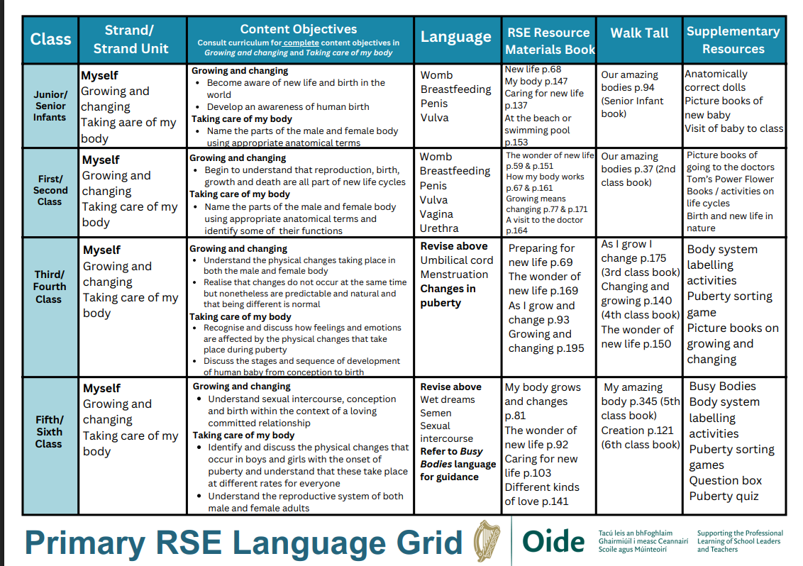

Appendix B: RSE Parental Withdrawal Form
Subject: Request to Withdraw My Child from Sensitive RSE Lessons
Date: __________
Dear Principal,
I, ________________________________________, parent/guardian of
________________________________________ in ________Class , wish to formally request that my child be withdrawn from the sensitive elements of the Relationships and Sexuality Education (RSE) programme as outlined in the school’s RSE Policy (2025).
I understand that:
- Relationships and Sexuality Education (RSE) is a mandatory component of the Social, Personal and Health Education (SPHE) curriculum as directed by the Department of Education and Youth.
- The school is required to teach the RSE programme each year using approved Departmental resources (Stay Safe, Walk Tall, RSE Resource Materials and will use Busy Bodies (HSE) for senior pupils).
- Sensitive topics include, but are not limited to: naming body parts, puberty, menstruation, conception and birth, as set out in the OIDE RSE Sensitive Topics Framework.
- Withdrawal from these lessons is permitted only in exceptional circumstances and must be done following consultation with the class teacher and/or the Principal.
- By choosing to withdraw my child, I accept full responsibility for teaching the equivalent sensitive content at home to ensure that my child receives a complete, accurate and developmentally appropriate understanding of the RSE curriculum in line with Department of Education guidance.
We/I confirm that We/I have read the St. Fergus’ NS RSE Policy (2025) and understand the purpose, structure and content of the programme being delivered in the school.
Signed: ___________________________ Signed: ____________________________
(Parent/Guardian) (Parent/Guardian)
Date: _________________________
Contact Number/Email: __________________________
C.F. Other side for School Use
For School Use Only:
Date received: ____________________________

Consultation held with parent(s) on: ____________________________

Principal’s signature: ____________________________

Class teacher’s signature: ____________________________

Appendix C: Core RSE Resources and Programmes
• Stay Safe Programme
• Walk Tall Programme
• Relationships and Sexuality Education
• Busy Bodies weblinks and Booklet
• Webwise and HTML Heroes
• Grow in Love
• PDST “Making the Links”
• OIDE Wellbeing and RSE Resources

