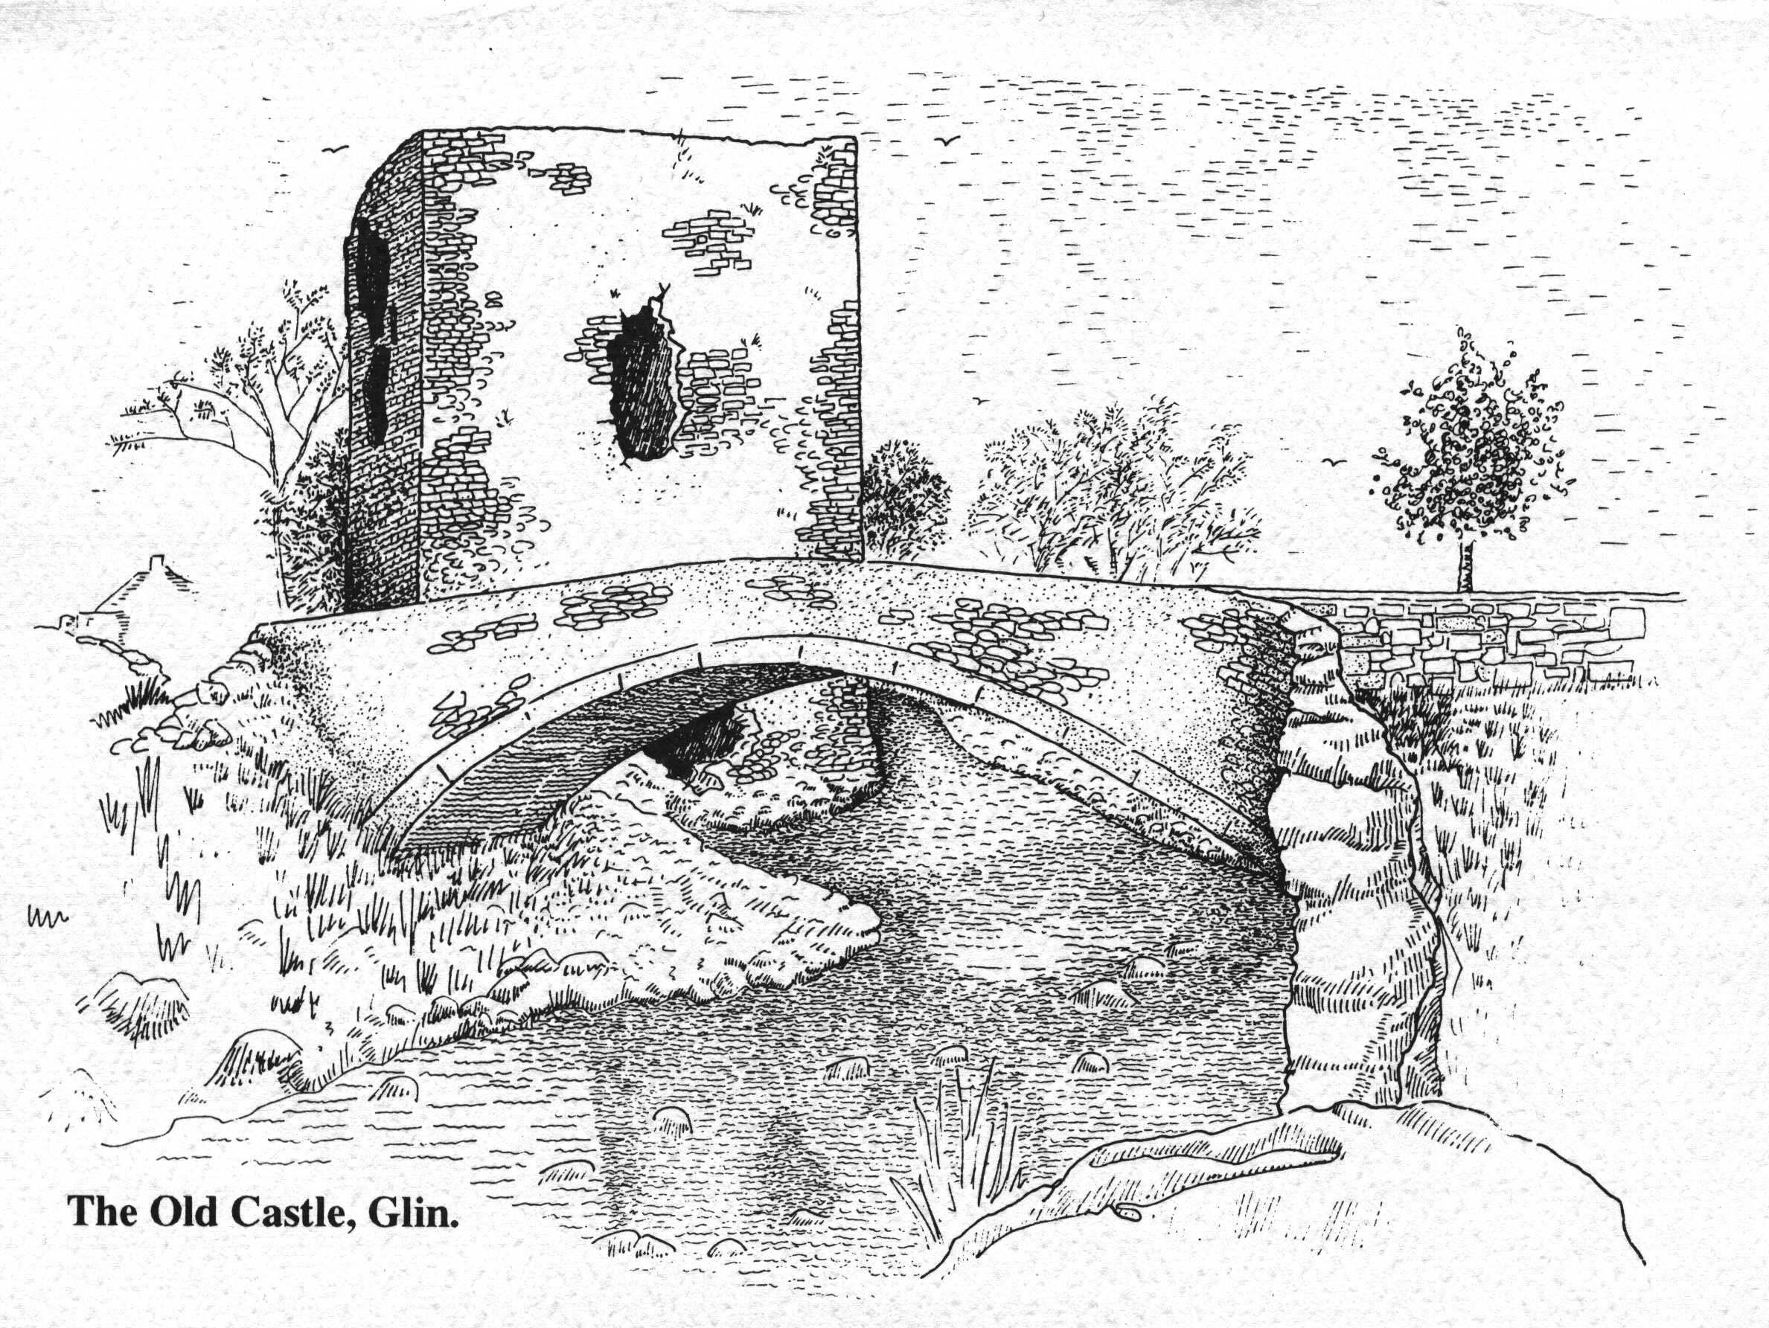
Scoil Náisiúnta Naomh Fheargus,
An Gleann,
Co. Luimnigh.

St.Fergus’ National School,
Glin,
Co. Limerick.
Tel:(068) 34344
E-Mail : office@stfergusns.ie
www.stfergusns.ie
Roll No. 20102T

Board of Management Agreed Report 2024

Chairperson: Fr. Tim Curtin
Principal: Mrs Deirdre Kennelly
Patron’s Nominee: Mr. Tommy Barrett
Staff Nominee: Mrs Carol Ann Healy
Communitee Nominees: Mrs Mary Moloney and Mr John Hogan
Parent Nominees: Ms Norma Harnedy and Mr Patrick Fitzgerald

A meeting of the BOM took place on the 18th of February 2025

-Career Breaks for 2025-2026 were ratified
-Splitting of Classes Policy was ratified and approved
-Fundraising events between now and June were approved
- Bake Sale
- Abseil in Thomond Park
- Church Gate Collection
-Bí Cineálta Policy (draft) was discussed and Restorative Practice approved for 2025-2026
-Emergency Works for electrics needed

-We will meet again during Term 3.

